

**SCHOOL OF ELECTRICAL ENGINEERING**

**COVID-19 HELPER APP**

*A project submitted in partial fulfillment of the requirements for the course Technical Answers for Real world Problems (TARP)*

**By**

Mujeeb Javed (19BEE1101)

Pranav Kulkarni (19BEE1059)

Titash Banerjee (19BEE1052)

Chirantan Paul (19BEE1179)

Ippili Pranay Kumar (19BEE1174)

Pronil Polpakkara (19BEE1073)

**Faculty Supervisor**

Prof. Anantha Krishnan V

Assistant Professor

(S.G)

**UNDERTAKING**

This is to declare that the project entitled “COVID-19 Helper App” is an original work done by undersigned, in partial fulfillment of the requirements for the Course Technical Answers for Real World Problems (TARP), VIT Chennai.

All the analysis, design and system development have been accomplished by the undersigned. Moreover, this project has not been submitted to any other college or university

Mujeeb Javed

Pranav Kulkarni

Titash Banerjee

Chirantan Paul

Ippili Pranay Kumar

Pronil Polpakkara

**ABSTRACT**

Our app helps people in making the decision of taking Covid Test . If the user of our app is given all the required information, our app will analyze the data provided . On the basis of the result, if the symptoms are mild then our app will suggest the user to be home quarantined and take medication. If the symptoms are worse, then our app will suggest the user to consult a doctor and also provide the availability of vaccination centers.

# **INTRODUCTION**

As we know the present situation of most of the people in this Covid-19 , they were facing difficulties in deciding whether to take Covid test or not. In taking the decision, our app will help people by providing a questionnaire that will analyze the answers given by them and on the basis of that it gives a result of whether to go to the hospital for Covid test or not. Also our app helps in vaccination, by providing the pin code of the location our app shows nearby vaccination centers and availability of vaccines .

# 

**MOTIVATION OF OUR APP**

**Arogya setu**

The Indian COVID–19 "contact tracing, syndromic mapping, and self-assessment" digital service Aarogya Setu (translation from Sanskrit: the bridge to health) is largely a mobile app developed by the National Informatics Center under the Ministry of Electronics and Information Technology (MeitY). In just 40 days, the app had surpassed 100 million downloads. The app's source code was made public on May 26th, amid rising privacy and security concerns.

**PREREQUISITES**

# **ABOUT ANDROID STUDIO**

# Built on JetBrains' IntelliJ IDEA software and developed exclusively for Android development, Android Studio is the official integrated development environment (IDE) for Google's Android operating system. It takes the position of the Eclipse Android Development Tools (E-ADT) as the primary IDE for developing native Android apps.

**ABOUT KOTLIN**

Kotlin is a type-inferred, cross-platform, statically typed, general-purpose programming language. Kotlin primarily targets the JVM, although it can also compile to JavaScript or native code via LLVM (for example, for frontend web projects using React) (e.g., for native iOS apps sharing business logic with Android apps).

# **WORKING**

1. VACCINE AVAILABILITY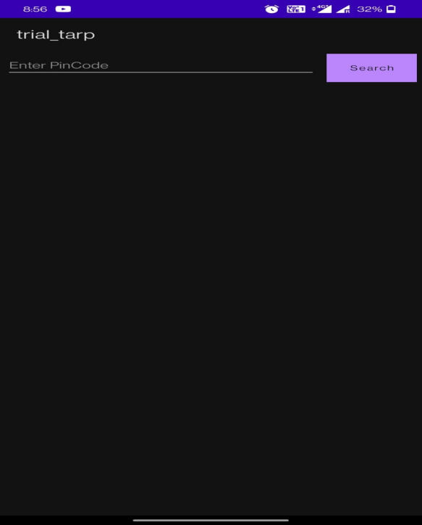

We will use Android Studio and work on developing our application in Kotlin. When we will open the application. When the application is opened you will see a search bar on top.

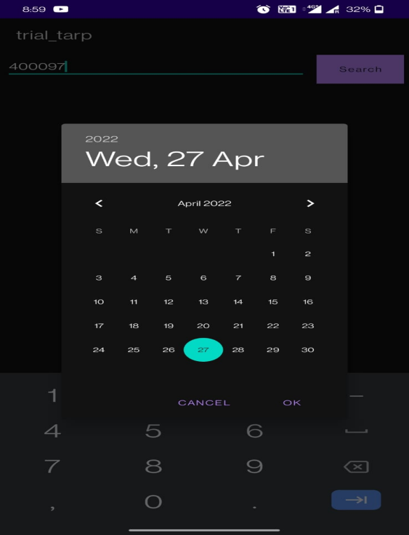

When you tap on it you will be asked to enter a pin code and after tapping the search button you will be asked to enter the date on a pop up window.

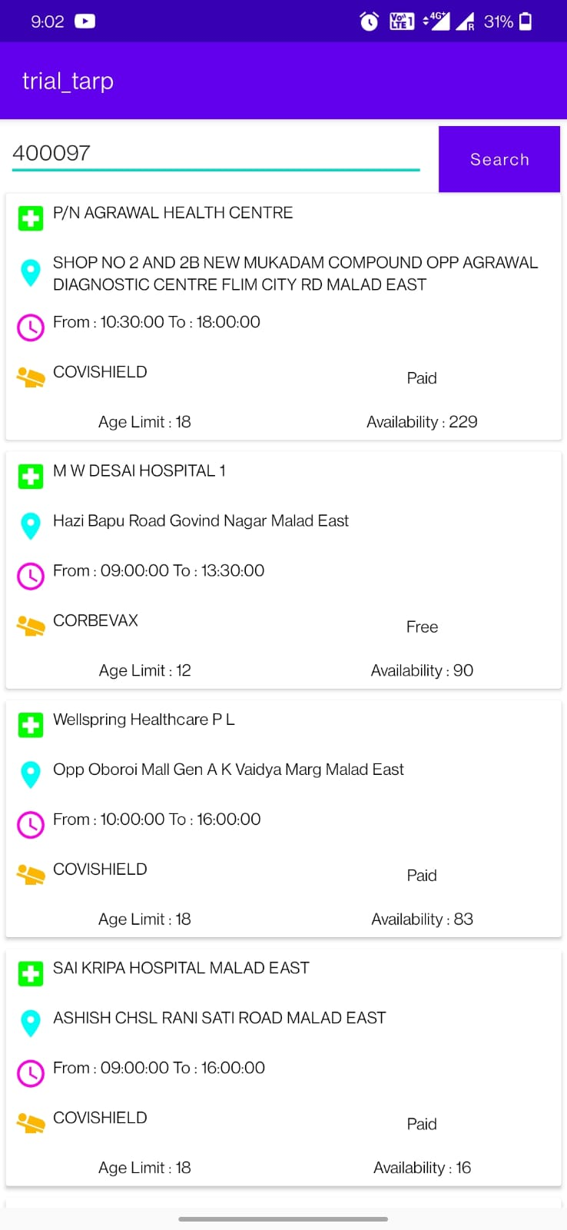

After selecting the date of vaccination you will be able to see the nearby available vaccination centers in the area.

This all happens with the help of an API that helps to determine the vaccine availability on a particular date in a certain area. In the end you will see the vaccination centers with various parameters like address, vaccination timing, type of vaccination, age limit, fee type (free/paid) and number of vaccines available.

1. AndroidManifest.xml

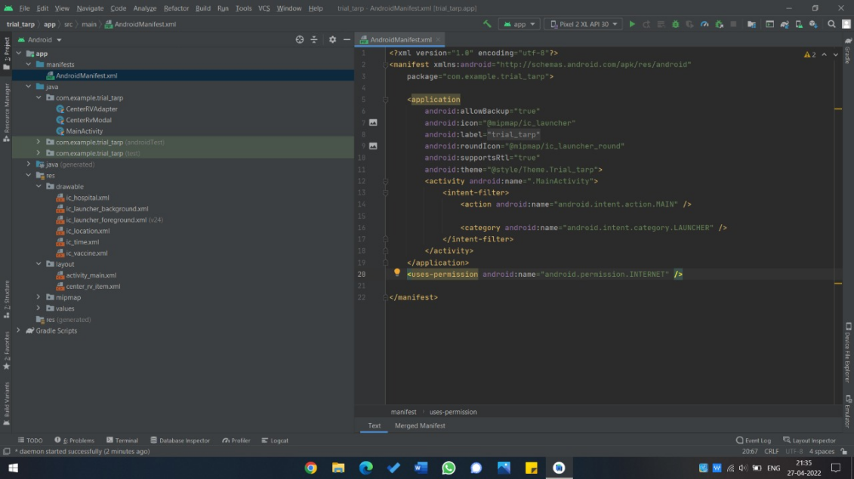

This file contains the information about the application we are making and is found at the root of the source set. We can set the theme, icon label, and internet permissions of the application in this file.

1. Main activity.kt

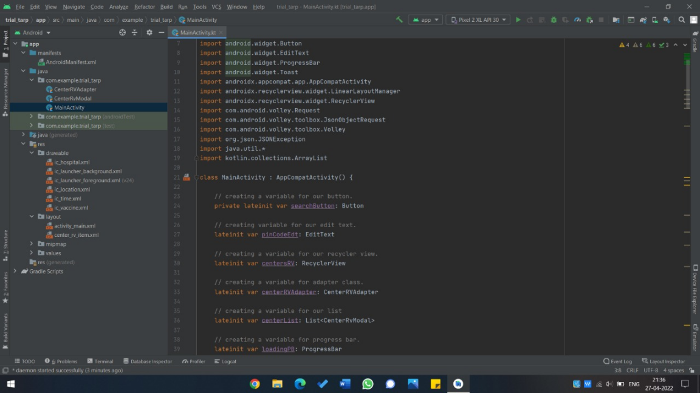

This paradigm is made easier by the Main activity file. When one file/class calls another, the calling file/class triggers a specific activity in the other file rather than the entire app. The Main activity serves as the starting point for an app's engagement with the user in this fashion. As a subclass of the Main activity class, we can create any number of activities.

To create the Main activity, open your manifest file and add an <activity> element as a child of the <application> element to declare your activity.

1. CenterRvModal.kt

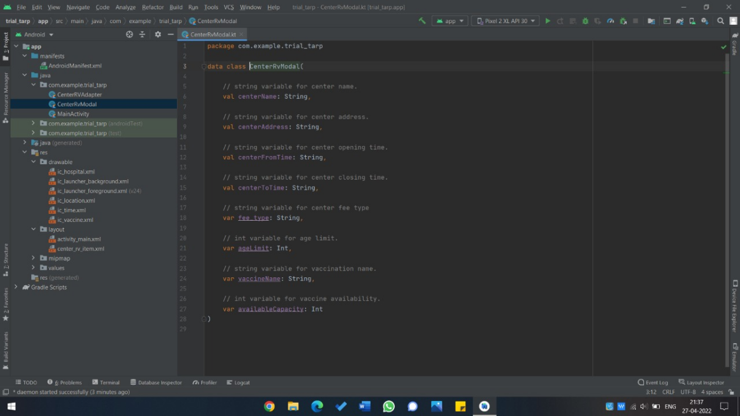

The CenterRvModal file is used to define the basic data type of various parameters displayed in the application, like center’s name, address etc. are string data type, while age limit, number of available vaccines are integer data types.

1. CenterRvAdapter.kt

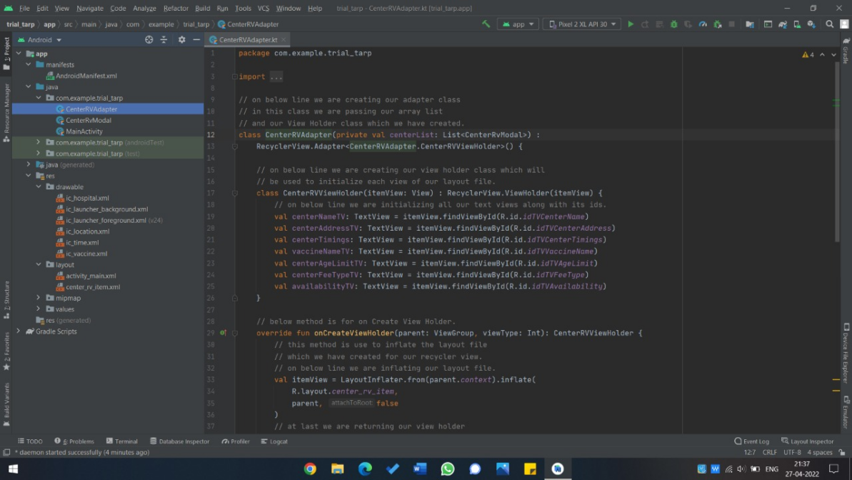

Adapters provide a binding from an app-specific data set to views that are displayed within the app. CenterRvAdapter file defines the set of functions that determine the values and activities to be displayed when the app is running and provides with the set of instructions for the user to interact with next.

1. Center_rv_item.xml

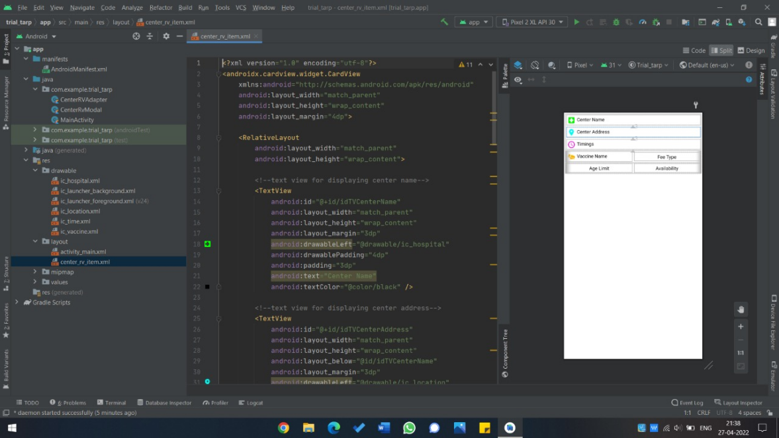

This xml file is used to stylize and trim the looks of the way the parameters are displayed in the application window. The file defines the width, height, margin, padding, colors etc. for each parameter separately and is imported to the Activity_main xml file to finalize the look of the application.

1. Activity_main.xml

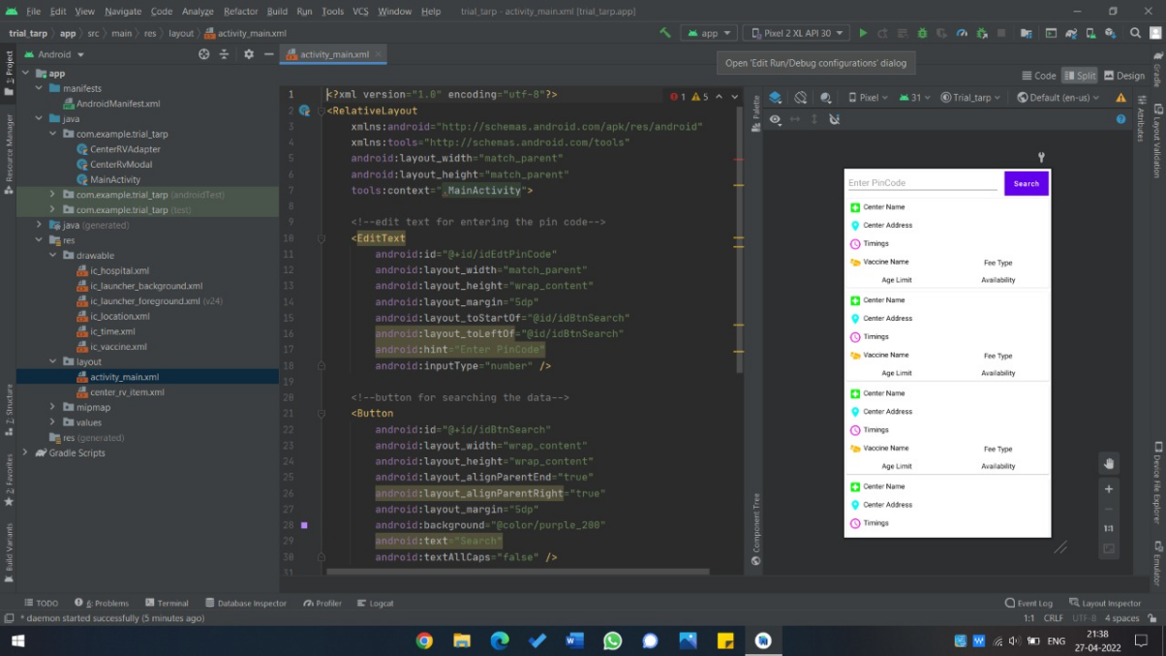

An Android app's user interface (UI) is organized as a hierarchy of layouts and widgets. The layouts are containers that govern the placement of parameters on the screen. Widgets are viewable objects, which includes UI elements like buttons and text/search boxes. Activity_main xml file helps in binding all the functions, parameters, containers, widgets, in one single format for easier access and reduce latency. Finally the application is wrapped with the gradle to build a .apk file and make it portable to other devices.

1. COVID QUESTIONNAIRE

1.Android Manifest

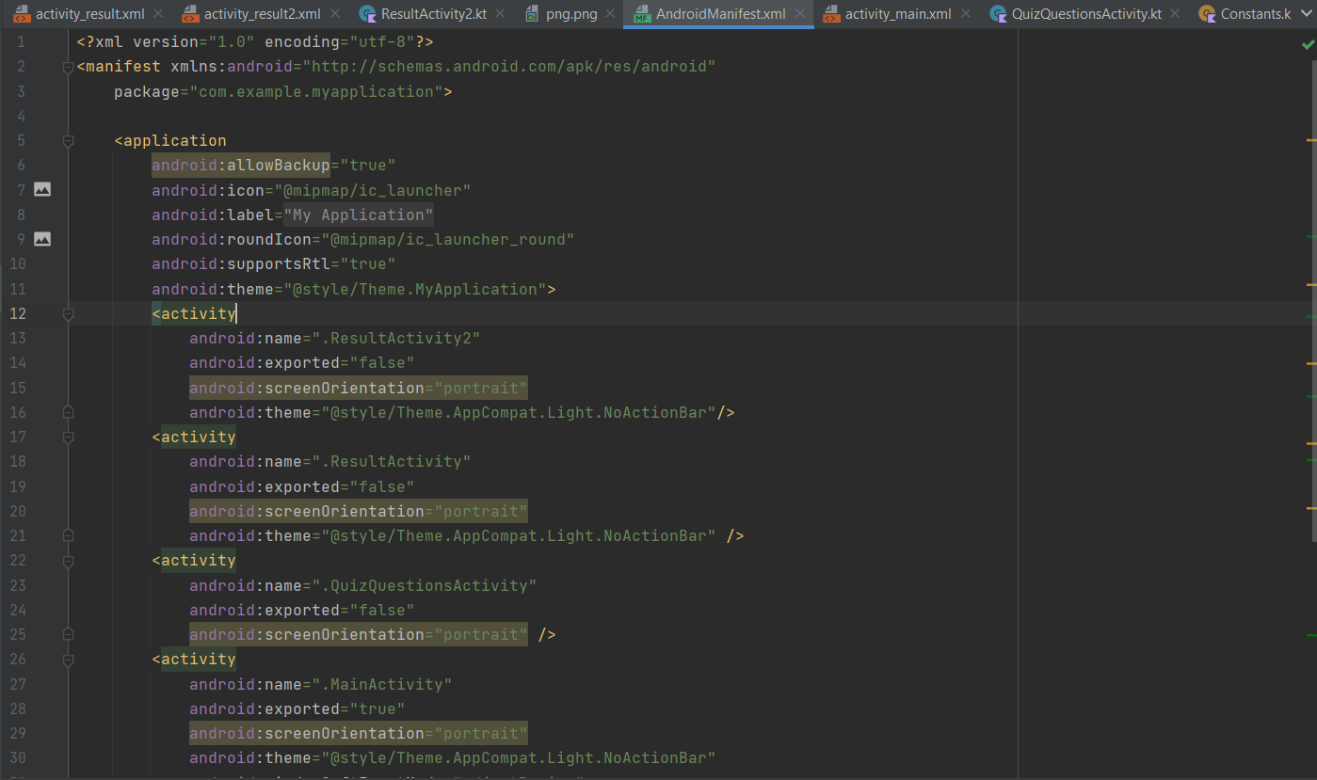

In this part of our app we focus upon giving structure and main UI to the app .In this portion we concentrate on the front end part giving shape to each button,text,and rest of the components that are visible to the user and are interact-able by the user till now these objects might not have a proper functionality but as we built screens related to one object it can be used by other screens as base reference where only variables have to be changed such as text and color but the base screen UI will be the same in the manifest

Activity screen

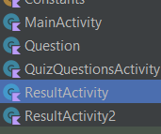

The activity screen gives functionality to the interact-able UI element that we have created in the manifest file it also includes the base code on the bases of which our app will do basic computation on bases of which our app will generate the result activities

Each activity has its own manifest file attached to it on which the UI is created and on the manifest file the functionality to UI elements is given to these XML files that are shown in the given figure below

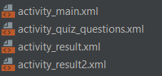

in our project we have four activity screen

Main Activity

This includes the initial page that will give the user options to start the quiz

The main activity includes the text box ,the start button to start the quiz

Quiz Questions Activity

This includes the basic code layout on how the quiz questions will be selected how the base values will be incremented and how these options will affect the constants given in the constants file the variables are given in the questions and these variables are manipulated in constants file

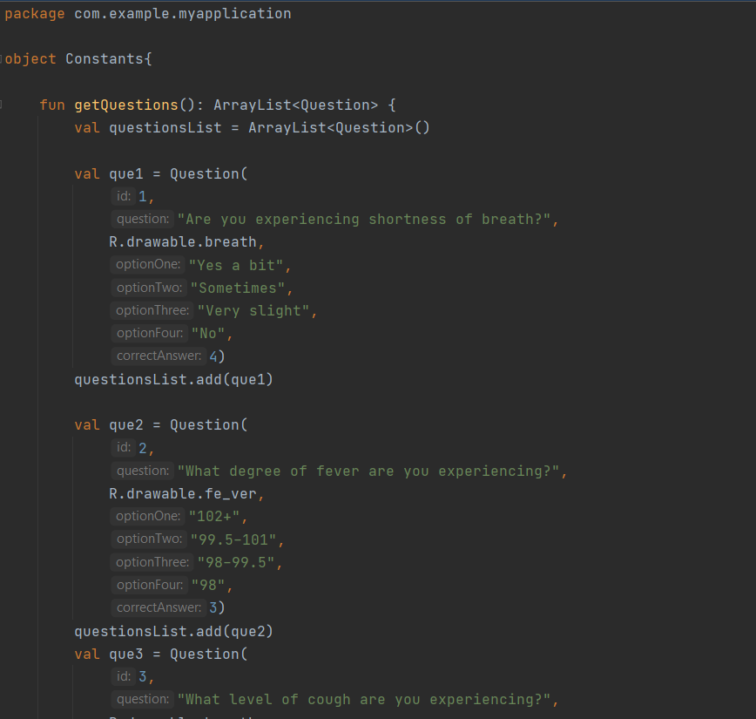

Constants file

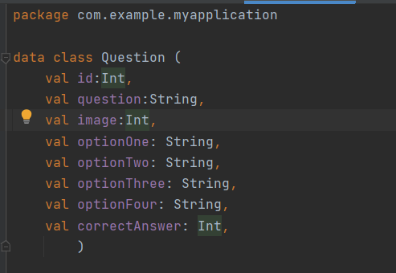

Questions file

The manifest of this file gives layout to the questions that can be used again and again using constants file .The constant file will include all the text changes and pictures based on the questions

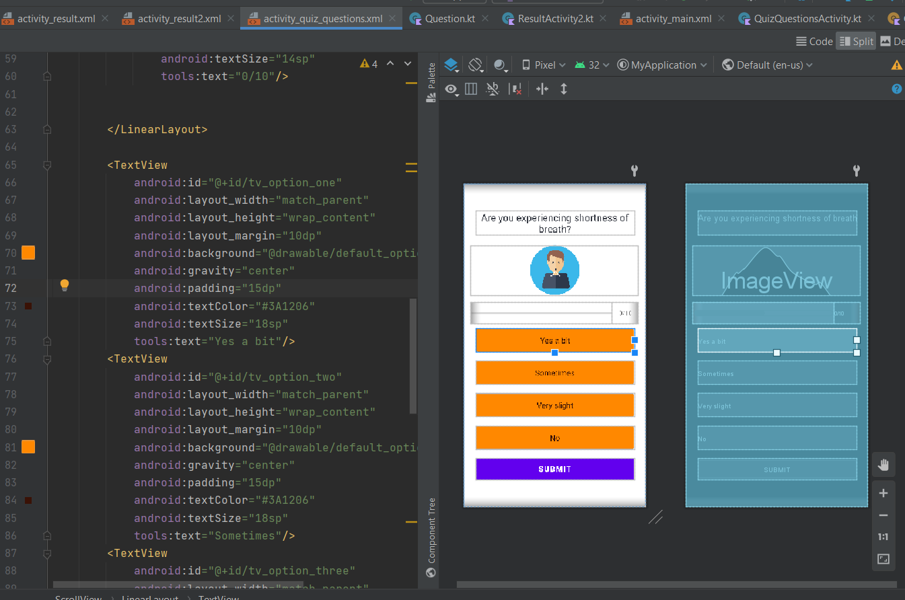

Result activity 1

Thus the Activity which include the code and the design layout for the final screen if the user is not detected with the symptoms of Covid-19 the manifest of this activity have the design layout that will be displayed at the end

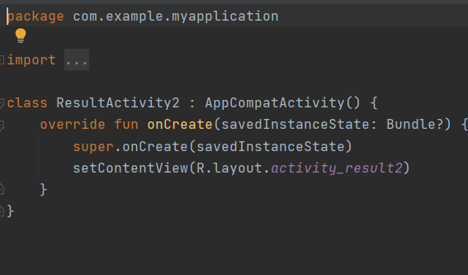

Result activity

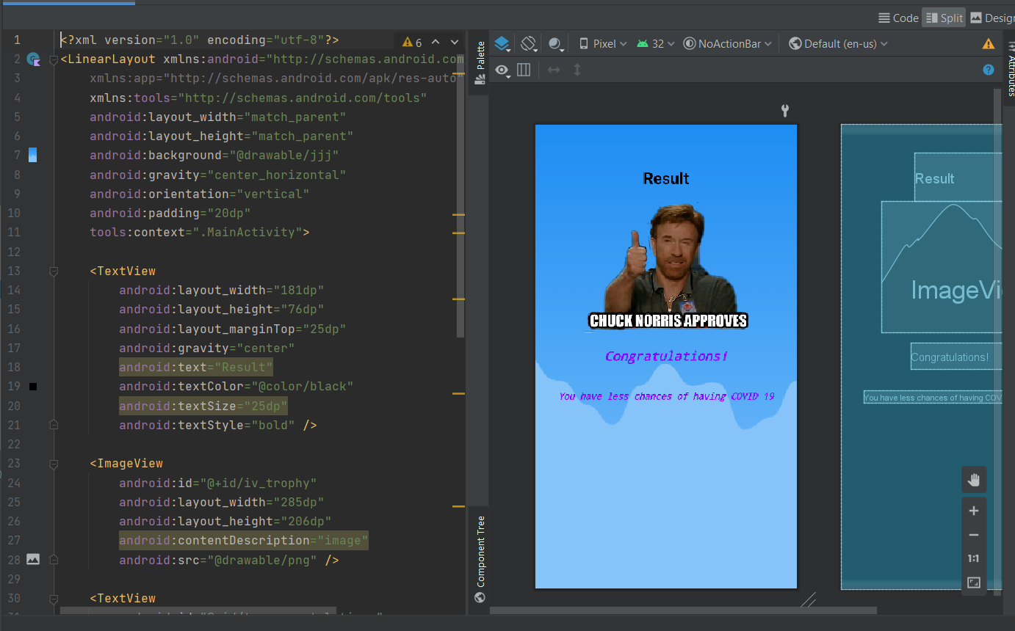

Design layout

Result activity 2

Thus the Activity which include the code and the design layout for the final screen if the user is detected with the symptoms of Covid-19 the manifest of this activity have the design layout that will be displayed at the end

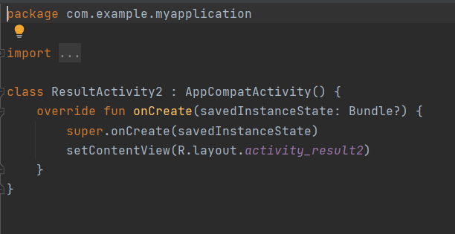

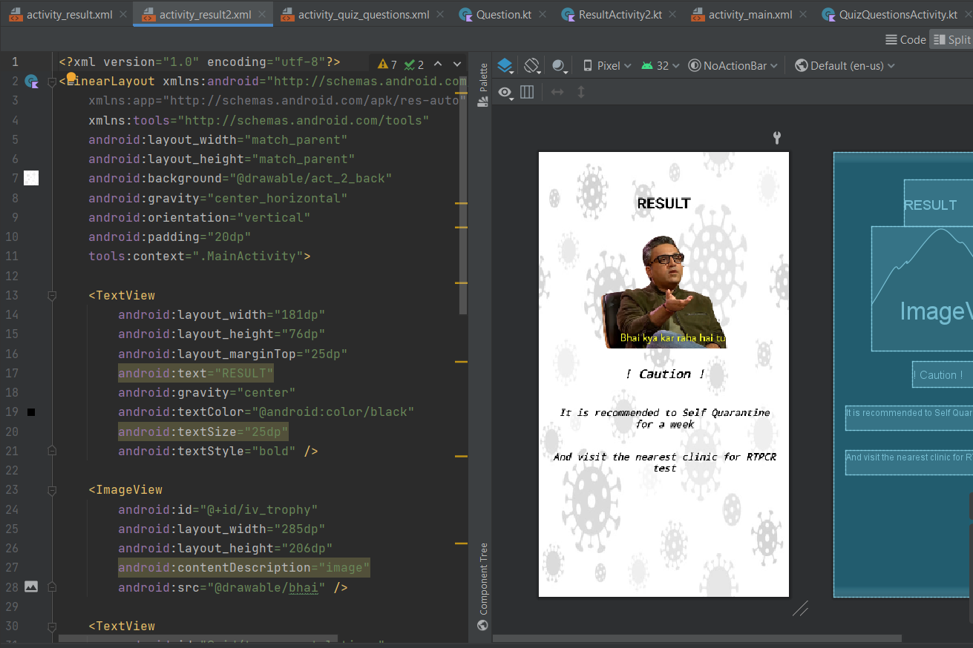

**TESTING OF THE APPLICATIONS**

The applications were tested on an android emulator created using the Android Virtual Device (AVD) manager, found in the Android Studio. We used a pixel 2 XL with API 30 to work on our application. After testing and debugging the app, we built a .APK file for our application that was launched on mobile devices through manual installation.

**OUTPUT**

VACCINE AVAILABILITY

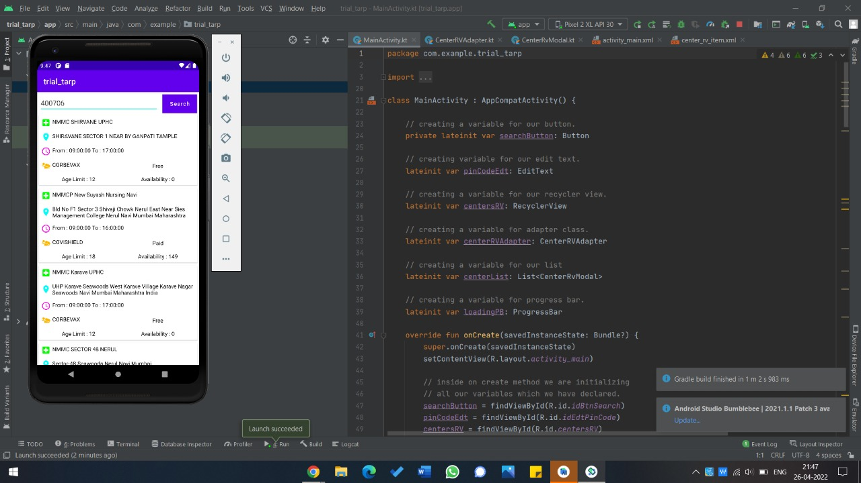

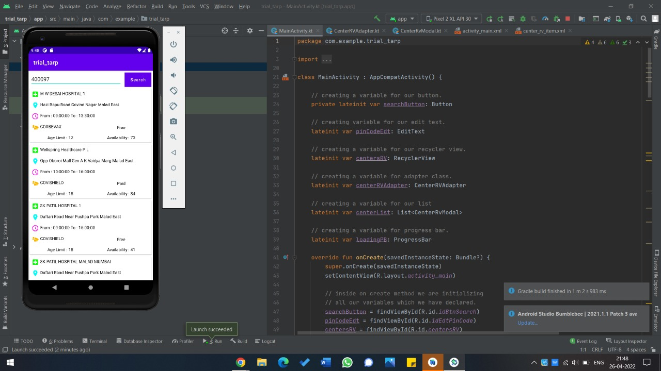

APP IN PHONE



**COVID QUESTIONNAIRE**

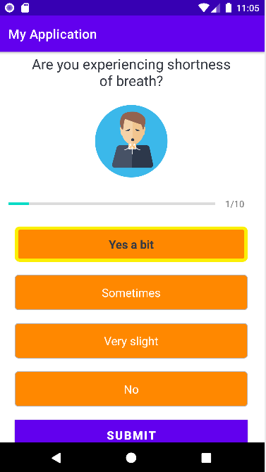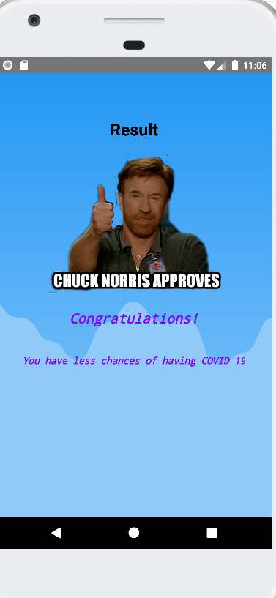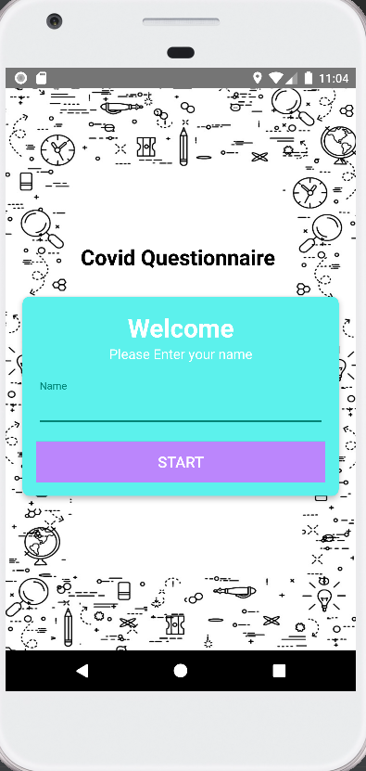

## **REFERENCES**

1.<https://developer.android.com/training/basics/firstapp/building-ui#:~:text=In%20the%20Project%20window%2C%20open,of%20the%20Android%20Studio%20screen>.

2.<https://www.aarogyasetu.gov.in/>

3.<https://www.w3schools.com/kotlin/index.php>

4.<https://kotlinlang.org/docs/server-overview.html>

5.<https://kotlinlang.org/docs/server-overview.html>

6.Zhang, M. J. Ventura and H. Yang, "Network Modeling and Analysis of COVID-19 Testing Strategies," 2021 43rd Annual International Conference of the IEEE Engineering in Medicine & Biology Society (EMBC), 2021, pp. 2003-2006, doi: 10.1109/EMBC46164.2021.9629754.

7.X. Zhang, M. Pettinati, A. Jalali, K. S. Rajput and N. Selvaraj, "Novel COVID-19 Screening Using Cough Recordings of A Mobile Patient Monitoring System," 2021 43rd Annual International Conference of the IEEE Engineering in Medicine & Biology Society (EMBC), 2021, pp. 2353-2357, doi: 10.1109/EMBC46164.2021.9630722.

8. Gupta, D. Rastogi, K. Chauhan and S. Sharma, "Comparative Analysis of the 1st and 2nd Wave of COVID–19 and Visualizing the Increasing and Decreasing of COVID–19," 2021 10th International Conference on System Modeling & Advancement in Research Trends (SMART), 2021, pp. 324-329, doi: 10.1109/SMART52563.2021.9676279.

9.N.Melek, "A Brief Dive into COVID-19 Cough Sound Data sets," 2021 Medical Technologies Congress (TIPTEKNO), 2021, pp. 1-4, doi: 10.1109/TIPTEKNO53239.2021.9632935.

10.Karabay, A. Kuzdeuov and H. A. Varol, "COVID-19 Vaccination Strategies Considering Hesitancy Using Particle-Based Epidemic Simulation," 2021 43rd Annual International Conference of the IEEE Engineering in Medicine & Biology Society (EMBC), 2021, pp. 1985-1988, doi: 10.1109/EMBC46164.2021.9630797.